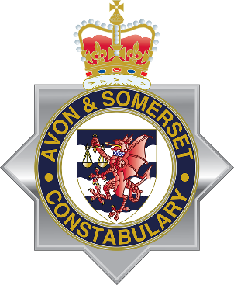 | 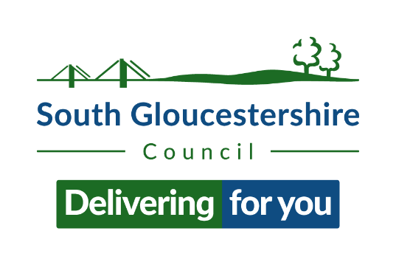
04 March 2024
A joint message from South Gloucestershire Council and Avon and Somerset Police
Dear parent/carer,
We are sure you are aware of recent shocking and tragic events in the wider Bristol area associated with knife crime and we recognise the impact these incidents are having on students and young people in South Gloucestershire as well as on families and the wider community.
We fully appreciate that you may have concerns about the safety of your child following these events, and so we are jointly writing to you to explain the work being undertaken in South Gloucestershire to tackle knife crime.
We want to reassure you that we understand and share your concerns about knife crime, and we are working together as partners and alongside our communities to tackle the root causes of this issue. South Gloucestershire Violence Reduction Partnership, which includes the council’s community safety team, children’s social care, police, schools and other partners, is committed to educating young people about the dangers and impacts of knife crime and is working hard to keep them safe.
As well as providing access to support and advice, South Gloucestershire Violence Reduction Partnership has commissioned Blunt Truth workshops in secondary schools where police and doctors talk to students about the devastating consequences of knife crime and the risks of carrying a weapon. They provide First Aid skills to help someone in an emergency and encourage young people to report any concerns to Fearless, the Crimestoppers service dedicated to young people. Age-appropriate workshops about belonging, and instilling positive values at an early age, are due to start in primary schools in March.
Bleed kits, which are attached to community defibrillators, have been installed in public places across South Gloucestershire for all to access in the event of a catastrophic trauma including a knife wound. There are also knife surrender bins located outside two South Gloucestershire police stations (Patchway and Kingswood) and in Broad Street, Staple Hill (opposite Page Park) to help encourage people to discard of weapons safely.
Other interventions in the community include Street Doctors and detached youth workers and crime prevention through sport activities.
We have also produced a really informative guide to knife crime for parents and carers which includes advice on starting conversations about knife crime and the dangers of carrying a bladed weapon. The guide also provides links and contacts for further support put together courtesy of the Ben Kinsella Trust, a charity which works to educate young people on the dangers of knife crime and help them make positive choices to stay safe. Further information is available on the council website and at the end of this letter.
We hope you find this information helpful.
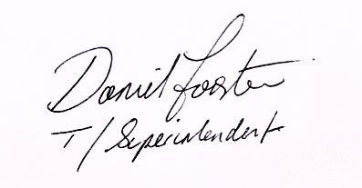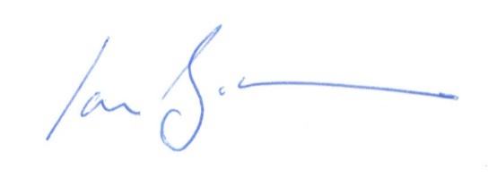
Dan Forster Cllr Claire Young Cllr Ian Boulton
Temporary Superintendent Leader Co Leader
Avon & Somerset Police South Gloucestershire Council South Gloucestershire Council

Advice for starting conversation with your child about the incidents
Talking about knife crime or knife carrying is part of the solution and can help save lives.
We encourage you to all have age-appropriate conversations with your children at home, to help them understand what’s happened and what they can do if they’re feeling worried.
Actively talking about the incidents and knife crime at home will also mean that if they do have any worries, they’re more likely to come and speak to you.
There are lots of different organisations that can help you with age-appropriate conversations. You can find general advice for talking about difficult topics on the NSPCC website, there are also places to go for age-specific advice:
For under-11s
- Resources like Talk PANTS will help.
- Make sure you’re using language they can understand.
- If you suspect grooming or exploitation, you can report this directly to CEOP.

For older children and teenagers
Their needs and behaviour will be changing and they may find talking to you about difficult topics embarrassing. They will still look to you for support, so it’s worth continuing to check in with them regularly, even if there’s nothing they want to talk about. There are some tips in the NSPCC's Positive Parenting guide and on its page on talking about difficult topics.

Advice on where to go for help if you think your child may be at risk from knife crime
In the first instance, if you have information that you think the police need to know to keep people safe from drug dealing, serious violence or exploitation you can tell them about it:
- If the child is at immediate risk call the police on 999
- By using the Avon and Somerset Police suspected crime form
- Calling 101
- In person at a police station
- Anonymously through Crimestoppers via 0800 555 111 or its Fearless service.

If you're concerned about the well-being of a child, please contact the council’s safeguarding team on 01454 866000.
Barnardo’s ROUTES service supports young people at the highest risk of exploitation or violence including young people who have been hurt before or risk hurting others. They work with young people up to 21. You can self-refer by contacting them directly on 0117 9349726.

What you can do to help keep your child safe
We know this can be a worrying time for parents and carers and that you will be keen to keep your child safe.
For more information on knife crime and what to do if you are worried by it, visit the Avon and Somerset Police website.

Help and support
There is help available for people who have been impacted by these events and are experiencing a reaction associated with trauma.
Common signs of the impacts of trauma include:
- feeling unable or not having anyone to talk to about what happened
- poor sleep due to intrusive thoughts or disturbing dreams
- experiencing overwhelming emotions or feeling numb
- feeling as if your relationships are suffering since the incident.
In the first instance, it’s important that if someone’s wellbeing or mental health is suffering they call 101 or contact their GP.
Mental health support can be accessed through Avon and Wiltshire Mental Health Partnership. Adults can call 0800 953 1919 and children can call 0800 953 9599.
Young Victims: The Young Victims Service (YVS) provides help and support to young people who have been victims of crime, anti-social behaviour or domestic abuse:
Bristol MIND: support with mental health
Off the Record (CAMHS): mental health support for young people aged 11 - 25
2 Wish: Support for those affected by sudden death in young people.
Childline: call 0800 11 11 (under 19)
Kooth: Online anonymous mental health support for young people
Shout: 24/7 support if you need to talk (or text, or online chat): text the word 'SHOUT' to 85258
Samaritans: call 116 123

If your child has information they wish to pass on about a crime:
Fearless: Part of Crimestoppers: Fearless enables young people to pass on information about crime 100% anonymously:

