Reading at St Andrew’s
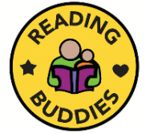
Reading Buddies
This term on a Friday afternoon, Years 1/2 and 5/6 have started ‘Reading Buddies’. The older children have been supporting the younger children with their reading. It’s lovely to see them all enjoying their books and spending time together.
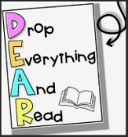
DEAR Time
All classes now have DEAR Time (Drop Everything and Read) at the end of every afternoon. This takes a variety of forms such as the teacher reading to the class, shared reading of the class text, children selecting their own book for quiet reading, or even children bringing in a text from home that they have read and wish to share with their class.
Library Books
Each class now has a weekly library session where the children will be able to select a book of their choice to bring home. There will be library signing in and out system, and the children may return and change their book each week.
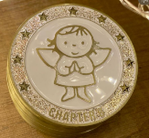
Weekly Star Readers
Our school expectation is that children read five times a week at home. This may be their reading book or an alternative text of their choice. On a Friday, the teachers total up each child’s reads at home. If the total is five or more, the children receive a ‘Star Reader’ certificate in class, and their name also gets put into the reading raffle.
The PTFA are kindly funding for a £10 book token for each of the classes - Infants, Years 3/4 and Years 5/6. The raffle will be drawn at the end of the Autumn, Spring and Summer terms.
Books home
All children will be bring home 2 books per week. These will be -
1. A book matched to your child’s phonics level.
2. A library book.
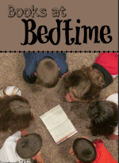
Books at Bed Time
We will be holding a ‘Books at Bedtime’ event on Wednesday 31st January, from 3:30-5:00pm. The children staying to this event after school, can bring pyjamas to change into at the end of the day. They will listen to stories in their classrooms read by a range of adults in school.
The event will finish by having hot chocolate in the school hall. This will be provided by the PTFA. We hope as many of the children as possible will be able to attend this event.
*If you have any questions about reading please speak to your child’s teacher, or Mrs Milverton the English Leader at St Andrew’s.

